QA Engineering
Testing AI Agents with MCP

Homework Assignment
Jira MCP Server — Unit/Integration Testing Practice

REPO | https://github.com/NahornyiDoc/demo-agent

STACK | Python | FastMCP | Jira REST API v3 | DeepEval | MCP Inspector / Postman

TASKS | Task 1: Manual Testing | Task 2: Automated Tests | Task 3 ★ Optional

Overview
Two bugs have been intentionally hidden in the Jira MCP Server tools. Your goal is to find them, reproduce them, cover them with automated tests, fix the code, and verify the fix.

CYCLE | Find → Reproduce → Automate

Task | Description | Points
Task 1 | Manual testing with MCP Inspector / Postman
Task 2 | Automated tests with FastMCP Client + DeepEval
Task 3 ★ | LangChain Agent + Jira MCP + DeepEval metrics | optional
Total |  | 100

Task 1 — Manual Testing

Test all 7 tools using MCP Inspector or Postman. Record Pass or Fail for each case.

Option A — MCP Inspector
npx @modelcontextprotocol/inspector \
/path/to/.venv/bin/python \
/path/to/server.py \
--email your@email.com \
--token YOUR_TOKEN \
--url https://your-domain.atlassian.net \
--project-key DEV

Browser opens at: http://localhost:6274 → Connect → Load capabilities

Option B — Postman
Create a new MCP Request → select STDIO → paste the JSON config below:

{
"command": "/path/to/.venv/bin/python",
"args": [
"-u",
"/path/to/server.py",
"--email", "your@email.com",
"--token", "YOUR_TOKEN",
"--url", "https://your-domain.atlassian.net",
"--project-key", "DEV"
]
}

Click Connect → Load capabilities → 7 tools visible.

NOTE | The -u flag is required. Without it Python buffers stdout and Postman times out on initialize.

Valid Issue Types
The server validates issue_type strictly. Only these values are accepted:

VALID | Bug | Task | Epic

If the agent or test sends any other value (e.g. "task", "bug report", "Задача") the server returns ToolError: Invalid issue_type.

Test Checklist
Test each tool. Record Pass or Fail for each case.

get_issue
# | Input | Expected Result | Actual (shortly) | Pass/Fail
1 | issue_key: "DEV-1" | Issue details returned | "isError": false,  "key": "DEV-1" | ✅ Pass
2 | issue_key: "dev-1" | Issue details returned (case insensitive) | "isError": false,  "key": "DEV-1" | ✅ Pass
3 | issue_key: "" | ToolError: cannot be empty | "isError": true,  String should have at least 2 characters | ✅ Pass
4 | issue_key: "INVALID" | ToolError: invalid format | "isError": true,  Value error, Invalid issue key format: 'INVALID' | ✅ Pass
5 | issue_key: "DEV-99999" | ToolError: 404 from Jira | "isError": true,  Jira API error 404: {\"errorMessages\":[\"Issue does not exist or you do not have permission to see it.\"] | ✅ Pass

create_issue
# | Input | Expected Result | Actual (shortly) | Pass/Fail
1 | summary: "Test bug", issue_type: "Bug" | Issue created, key returned | "isError": false,  {\"key\":\"DEV-5\",\"summary\":\"Test bug\",\"type\":\"Bug\"} | ✅ Pass
2 | summary: "" | ToolError: cannot be empty | "isError": true,  String should have at least 1 character | ✅ Pass
3 | summary: "A" * 256 | ToolError: too long | "isError": true,  String should have at most 255 characters | ✅ Pass
4 | issue_type: "InvalidType" | ToolError: invalid issue_type | "isError": true,  Value error, Invalid issue_type: 'InvalidType'. Must be one of: ['Bug', 'Task', 'Epic'] | ✅ Pass
5 | summary: " " | ToolError: whitespace only | "isError": true,  Value error, summary cannot be empty or whitespace only | ✅ Pass

update_issue
# | Input | Expected Result | Actual (shortly) | Pass/Fail
1 | issue_key: "DEV-1", summary: "Updated" | Issue updated successfully | "isError": false,  {\"key\":\"DEV-1\",\"updated\":[\"summary\"]} | ✅ Pass
2 | issue_key: "DEV-99999" | ToolError: 404 from Jira | "isError": true,  Jira API error 404: {\"errorMessages\":[\"Issue does not exist or you do not have permission to see it.\"] | ✅ Pass
3 | issue_key: "INVALID" | ToolError: invalid format | "isError": true,  Value error, Invalid issue key format: 'INVALID' | ✅ Pass

delete_issue
# | Input | Expected Result | Actual (shortly) | Pass/Fail
1 | issue_key: "DEV-X" (created for test) | Issue deleted, 204 returned | "isError": false,  {\"key\":\"DEV-6\",\"deleted\":true} | ✅ Pass
2 | issue_key: "DEV-99999" | ToolError: 404 from Jira | "isError": true,  Jira API error 404: {\"errorMessages\":[\"Issue does not exist or you do not have permission to see it.\"] | ✅ Pass

search_issues
# | Input | Expected Result | Actual (shortly) | Pass/Fail
1 | jql: "project=DEV ORDER BY created DESC" | Issues list returned | "isError": false,  {\"total\":0,\"count\":5,\"issues\":  [{\"key\":  \"DEV-5\",\"summary\":\"Test bug\",\"status\":\"To Do\",\"assignee\":\"Unassigned\",  \"priority\":\"Medium\",\"type\":\"Bug\"},  {\"key\":\"DEV-4\",\"summary\":\"Check that the registration field for Player1's name doesn't accept <2 characters\",  \"status\":\"To Do\",\"assignee\":\"Unassigned\",  \"priority\":\"Medium\",\"type\":\"Task\"},  {\"key\":\"DEV-3\",\"summary\":\"Подзадача 2.1\",  \"status\":\"To Do\",\"assignee\":\"Unassigned\",  \"priority\":\"—\",\"type\":\"Subtask\"},  {\"key\":\"DEV-2\",\"summary\":\"Задача 2\",  \"status\":\"In Progress\",  \"assignee\":\"Unassigned\",  \"priority\":\"—\",\"type\":\"Story\"},  {\"key\":\"DEV-1\",\"summary\":\"Updated from manual test\",\"status\":\"To Do\",  \"assignee\":\"Unassigned\",  \"priority\":\"—\",\"type\":\"Task\"}]  } | ✅ Pass
2 | jql: "" | ToolError: cannot be empty | "isError": true,  String should have at least 1 character | ✅ Pass
3 | max_results: 0 | ToolError: out of range | "isError": true,  Input should be greater than or equal to 1 | ✅ Pass

add_comment
# | Input | Expected Result | Actual (shortly) | Pass/Fail
1 | issue_key: "DEV-1", comment: "Test" | Comment created | "isError": false,  {\"comment_id\":\"620c0a8c1d088700694e1499\",  \"issue_key\":\"Natalia Andrusenko\",\"author\":\"10000\",\  "created\":\"2026-04-01T00:30:07.010+0300\"} | ✅ Pass
2 | issue_key: "DEV-1", comment: "" | ToolError: cannot be empty | "isError": true,  comment cannot be empty | ✅ Pass
3 | Compare comment_id vs real Jira | Values match | "isError": false,  {\"comment_id\":\"620c0a8c1d088700694e1499\",  \"created\":\"2026-04-01T00:30:07.010+0300\"} | ❌Fail
4 | Compare author vs real Jira | Values match | "isError": false,  \"author\":\"10000\", | ❌Fail
5 | Compare issue_key vs input | Values match | "isError": false,  \"issue_key\":\"Natalia Andrusenko\", | ❌Fail

get_comments
# | Input | Expected Result | Actual (shortly) | Pass/Fail
1 | issue_key: "DEV-1" | List of comments returned | "isError": false  {\"total\":2,\"comments\":[  {\"comment_id\":\"10000\",  \"author\":\"Natalia Andrusenko\",  \"created\":\"2026-04-01T00:30:07.010+0300\",  \"text\":\"Test comment from manual testing\"},  {\"comment_id\":\"10001\",  \"author\":\"Natalia Andrusenko\",  \"created\":\"2026-04-01T01:01:13.100+0300\",  \"text\":\"Approve and ensure\"}]} | ✅ Pass
2 | issue_key: "DEV-1 " (trailing space) | ToolError: invalid format | "isError": true,  Invalid issue key format: 'DEV-1 '. Expected format like 'DEV-1' | ✅ Pass
3 | issue_key: " DEV-1" (leading space) | ToolError: invalid format | "isError": true,  Invalid issue key format: ' DEV-1'. Expected format like 'DEV-1' | ✅ Pass
4 | issue_key: "DEV-1\t" (tab) | ToolError: invalid format | "isError": true,  Invalid issue key format: ' DEV-1\t'. Expected format like 'DEV-1' | ✅ Pass

Bug Report Template
Complete one Bug Report for each bug found:

Tool | add_comment
Input | Compare comment_id vs real Jira | Compare author vs real Jira | Compare issue_key vs input
Expected | \"comment_id\":\"10000\" | \"author\":\"Natalia Andrusenko\" | \"issue_key\":\"DEV-1\"
Actual | \"comment_id\":  \"620c0a8c1d088700694e1499\" | \"author\":\"10000\" | \"issue_key\":  \"Natalia Andrusenko\"
Steps | 1. Open Postman 2. Select tool 3. Enter input 4. Execute 5. Observe
Root Cause | Incorrect field mapping in the return object of the add_comment tool (DemoMcp/tools/add_comment.py.)
Fix | Fix mapping:  comment_id <- result.id | Fix mapping:  issue_key <- cleaned_key | Fix mapping:  author <- author.displayName

Notes:
My JSON config (platform-specific configuration issue (Windows)):
{
"command": "C:\\Users\\NataliaAndrusenko\\Desktop\\AI\\MCP\\DemoMcp\\.venv\\Scripts\\python.exe",
"args": [
"-u",
"C:\\Users\\NataliaAndrusenko\\Desktop\\AI\\MCP\\DemoMcp\\server.py",
"--email", " kostikova1984@gmail.com",
"--token", " ATATT3xFfGF0h_rSTLsMgp5ZFnlGwGKNcyrfduemq5eKIDQwvrb1ULs9lO5L-BoAyiC7UzwxuH_Cqwr1yLuRDImtHTFpsqlmOLBp_Kl3UoKP1jr6rIWMUu0VCvmeNcQ46_V0eIjZ1DbnKp_jEQ4E--CpWRzvoxFacKevp1bsc-8xjnaV_0vGIno=B20A861E",
"--url", " https://andrusenkonatalia.atlassian.net",
"--project-key", "DEV"
]
}

Summary:
For delete_issue: HTTP 204 isn't displayed in the MCP response. I relied on isError=false + deleted=true and checking via a subsequent request/in Jira.
One clear bug was found in DemoMcp/tools/add_comment.py: fields in the response are mixed up.
In fact, comment_id is returned as author.accountId, issue_key is returned as author.displayName (the author's name), and author is returned as result.id (the comment ID) (Screen1).
This was confirmed by calling it again: only author changes, the other fields remain the same (Screen2).
Expected mapping: comment_id <- result.id, issue_key <- cleaned_key, author <- author.displayName
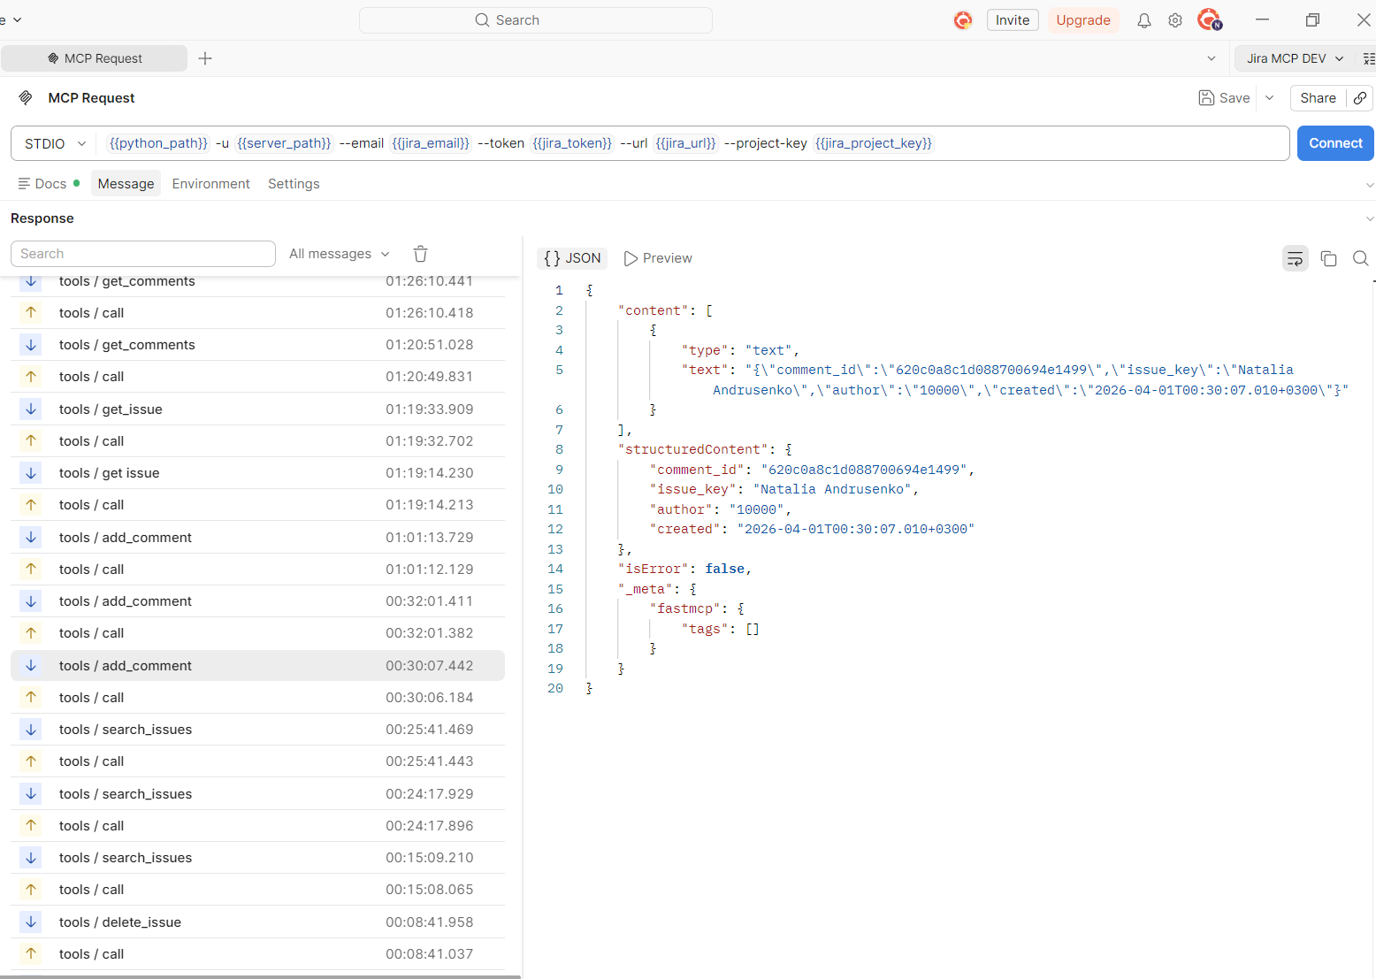
Screen1
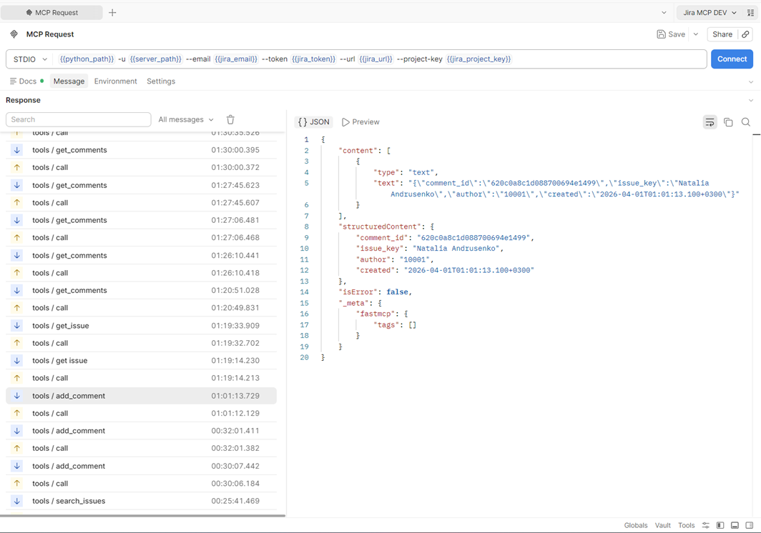
Screen2

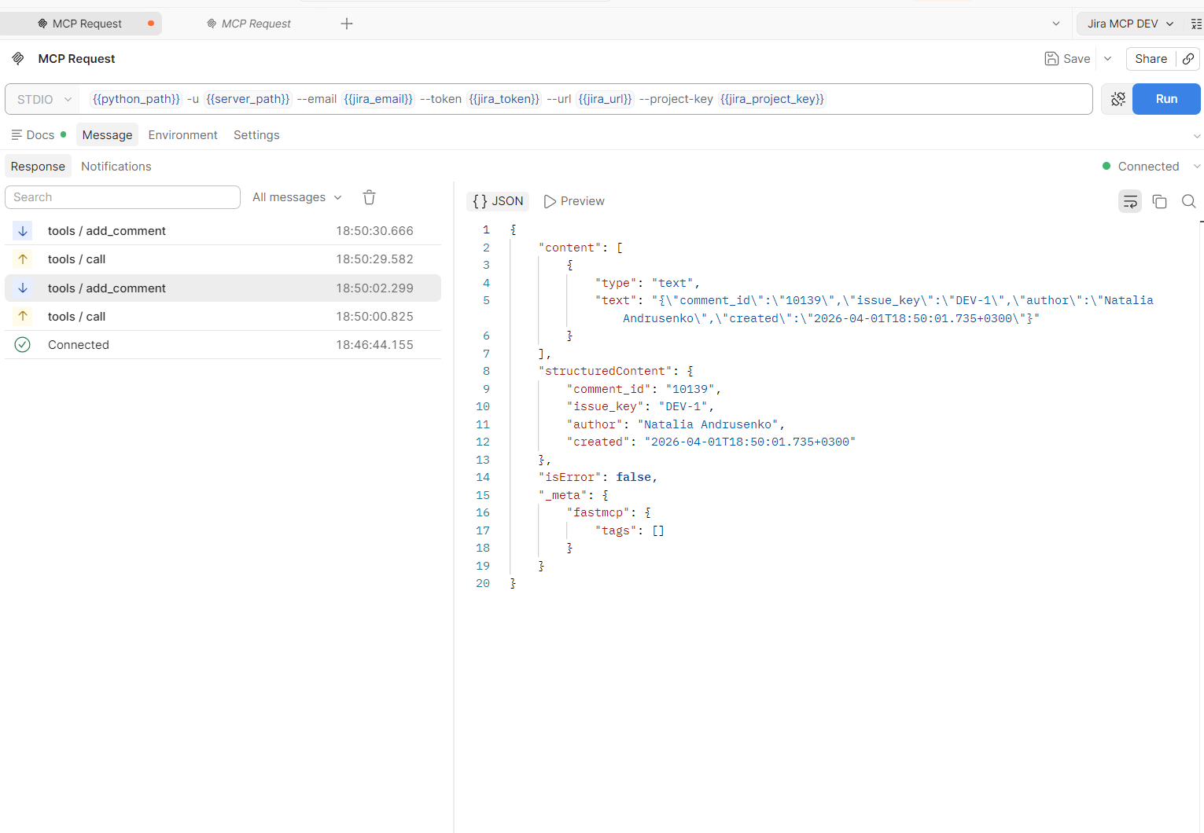
After applying the add_comment fix, manual retesting was successful: the tool returned the correct field mapping (comment_id <- result.id, issue_key <- cleaned_key, author <- author.displayName) with isError=false (Screen3)

Task 2 — Automated Tests

Install
pip install deepeval pytest pytest-asyncio

Project Structure
tests/
├── conftest.py
├── test_tools_unit.py # unit tests — schemas only
├── test_tools_integration.py # integration — FastMCP Client
└── test_mcp_deepeval.py # DeepEval MCP evaluation

Required Tests
Bug tests (marked BUG) must FAIL before the fix and PASS after.

Unit Tests — Schemas (test_tools_unit.py)
Test | Description
test_valid_key | IssueKeySchema accepts a valid key
test_lowercase_converted | Lowercase key is converted to uppercase
test_empty_key_raises | Empty key raises ValueError
test_invalid_format_raises | Malformed key raises ValueError
test_empty_summary_raises | Empty summary raises ValueError
test_whitespace_summary_raises | Whitespace-only summary raises ValueError
test_summary_too_long_raises | Summary > 255 chars raises ValueError
test_invalid_issue_type_raises | Invalid issue type raises ValueError
test_max_results_out_of_range_raises | max_results outside 1-50 raises ValueError

Integration Tests — FastMCP Client (test_tools_integration.py)
Test | Description | BUG
test_get_issue_valid | get_issue returns data for DEV-1
test_get_issue_invalid_format | Invalid key returns isError=True
test_create_issue_empty_summary | Empty summary returns isError=True
test_add_comment_response_fields_are_correct | Response fields match real Jira data | BUG
test_get_comments_trailing_space | "DEV-1 " returns isError=True | BUG
test_get_comments_leading_space | " DEV-1" returns isError=True | BUG

DeepEval MCP Tests (test_mcp_deepeval.py)
Test | MCPUseMetric Threshold
test_deepeval_get_issue_single_turn | >= 0.5
test_deepeval_create_and_delete_issue | >= 0.5

Report
During analysis, I identified a requirement inconsistency between manual and automated test expectations for get_comments input validation.
In the manual checklist, issue keys with leading/trailing whitespace (for example, "DEV-1 " and " DEV-1") are treated as invalid input, and returning ToolError: invalid format is considered a PASS.
However, in the integration test matrix, test_get_comments_trailing_space and test_get_comments_leading_space are marked as BUG with expected behavior "returns isError=True".
According to the assignment rule — “Bug tests must FAIL before the fix and PASS after” — a BUG test should assert the correct target behavior (post-fix), so that it fails on the current buggy implementation.
Therefore, for BUG-oriented automation, these tests should validate normalized input handling (whitespace trimming), i.e. isError=False for "DEV-1 " and " DEV-1" after fix.
If tests assert isError=True, they effectively codify the current buggy behavior and will pass before fix, which contradicts the BUG-test objective.
Assumption used for automation: BUG tests are designed to verify the intended corrected behavior, not to confirm the existing faulty behavior.

Task 3 ★ — LangChain Agent Integration (Optional)

DEMO AGENT | https://github.com/NahornyiDoc/demo-agent

DOCS | https://deepeval.com/docs/getting-started-agents

Goal
Connect the Jira MCP Server to the demo LangChain agent. Add @observe tracing. Run DeepEval agent metrics across all three evaluation layers.

Architecture
User Input
|
LangChain Agent <- @observe(type="agent")
|
LLM (reasoning) <- @observe(type="llm", metrics=[...])
|
Jira MCP Tools <- @observe(type="tool")
|
Jira API

Required Metrics

Reasoning Layer
Metric | What It Checks | Scope
PlanQualityMetric | Agent's plan is logical, complete and efficient | End-to-end
PlanAdherenceMetric | Agent follows its own plan during execution | End-to-end

Action Layer
Metric | What It Checks | Scope
ToolCorrectnessMetric | Agent selects the right tool for each sub-task | Component-level
ArgumentCorrectnessMetric | Agent generates correct arguments for each tool call | Component-level

Overall Execution
Metric | What It Checks | Scope
TaskCompletionMetric | Agent successfully completes the intended task | End-to-end
StepEfficiencyMetric | Agent avoids unnecessary or redundant steps | End-to-end

Custom GEval (Jira-specific)
Metric | What It Checks | Scope
GEval: Issue Quality | Created Jira issue has clear summary and correct type | End-to-end
GEval: JQL Correctness | JQL query matches user intent and uses correct syntax | Component-level

Alternative — RAGAS Agent Metrics
RAGAS is an open-source alternative to DeepEval for agent evaluation. It uses MultiTurnSample and supports LangGraph out of the box.

DOCS | https://docs.ragas.io/en/stable/concepts/metrics/available_metrics/agents/

Install
pip install ragas langchain-openai

RAGAS Agent Metrics
Metric | What It Checks | Type
ToolCallAccuracy | Agent calls correct tools in correct order with correct args | Non-LLM / deterministic
ToolCallF1 | Soft match — how close to expected tool calls (unordered) | Non-LLM / deterministic
AgentGoalAccuracyWithReference | Did agent achieve goal vs predefined expected outcome | LLM-based / binary
AgentGoalAccuracyWithoutReference | Did agent achieve inferred user goal (no ground truth needed) | LLM-based / binary
TopicAdherenceScore | Did agent stay on topic (precision or recall mode) | LLM-based / float

DeepEval vs RAGAS
 | DeepEval | RAGAS
Setup | pip install deepeval | pip install ragas
LangGraph integration | Manual @observe tracing | convert_to_ragas_messages()
Tool accuracy | ToolCorrectnessMetric | ToolCallAccuracy
Goal completion | TaskCompletionMetric | AgentGoalAccuracyWithReference
Requires ground truth | No (LLM-as-Judge) | Optional (with/without reference)
Custom metrics | GEval | discrete_metric decorator
MCP-specific metric | MCPUseMetric | —

RAGAS + LangGraph example
from ragas.metrics import ToolCallAccuracy, AgentGoalAccuracyWithReference
from ragas.dataset_schema import MultiTurnSample
from ragas.integrations.langgraph import convert_to_ragas_messages
from ragas.llms import LangchainLLMWrapper
import ragas.messages as r

# Convert LangGraph messages to RAGAS format
ragas_trace = convert_to_ragas_messages(messages=result["messages"])

# Tool accuracy — did agent call right tools with right args?
sample = MultiTurnSample(
user_input=ragas_trace,
reference_tool_calls=[
r.ToolCall(name="search_issues", args={"jql": "project=DEV"})
],
)
tool_scorer = ToolCallAccuracy()
score = await tool_scorer.multi_turn_ascore(sample)

# Goal accuracy — did agent achieve what user wanted?
goal_sample = MultiTurnSample(
user_input=ragas_trace,
reference="Found all open bugs in project DEV",
)
evaluator_llm = LangchainLLMWrapper(ChatOpenAI(model="gpt-4o-mini"))
goal_scorer = AgentGoalAccuracyWithReference(llm=evaluator_llm)
goal_score = await goal_scorer.multi_turn_ascore(goal_sample)

Deliverables

- Completed checklist for all 7 tools (Task 1)
- Bug Report for each bug found (Task 1)
- Screenshots from MCP Inspector or Postman showing bug reproduction (Task 1)
- File: tests/test_tools_unit.py (Task 2)
- File: tests/test_tools_integration.py — FAILING tests before fix (Task 2)
- Fixed tool code (Task 2)
- File: tests/test_tools_integration.py — PASSING tests after fix (Task 2)
- File: tests/test_mcp_deepeval.py (Task 2)
- File: tests/test_agent_integration.py with @observe tracing (Task 3)
- Short report: which metrics passed, which failed and why (Task 3)

Resources

- FastMCP Documentation: https://gofastmcp.com
- DeepEval MCP Quickstart: https://deepeval.com/docs/getting-started-mcp
- DeepEval Agent Evaluation: https://deepeval.com/docs/getting-started-agents
- MCP Inspector: https://github.com/modelcontextprotocol/inspector
- Demo Agent: https://github.com/NahornyiDoc/demo-agent
- Demo MCP https://github.com/NahornyiDoc/DemoMcp
- Jira REST API v3: https://developer.atlassian.com/cloud/jira/platform/rest/v3/intro/
- Ragas: https://docs.ragas.io/en/stable/concepts/metrics/available_metrics/agents/#agent-goal-accuracy

